# Color Vision

# 1 Enhancement Feature: The Challenges

This is a list of the ideas for challenges to test and enhance color vision.

## 1.1 Challenge: Match color game

The player will have a Time limit of 120sec to get maximum matches as he can.  
for every match, the score will increase.  
the total score will be added to his global score.

### 

### 1.1.1 Mechanic: Gameplay and score

* level 1:the player will have to move one slider with half move ability to match the color in the middle of the shape.
* level 2: the player will have to move two sliders to match the color in the middle of the shape. the third slider will be fixed.
* level 3:the player will have to move one sliders to match different shapes at the same time to the color in the middle of the shape. the third slider will be fixed.
* level 4: the player will have to move the three sliders to match the color in the middle of the shape.

## 1.2 Challenge: Remember the color

Each player will get 5 distinct colors the task is to remember the color it will appear for 10-15 seconds after that the player will choose from 5 to 10 different colors which one correctly matched the seen color.  
each round will have a 20-point score.

# 2 Enhancement Feature: Color vision testing

The User will test his Color vision level throw mini-games like those below.  
the difficulty will increase until the player gets 3 failed.  
in the 3rd one, the player level will be detected.

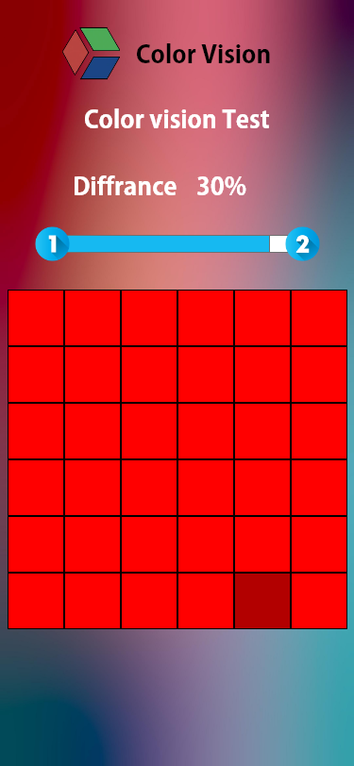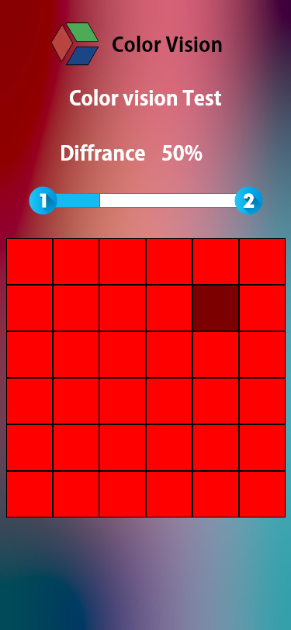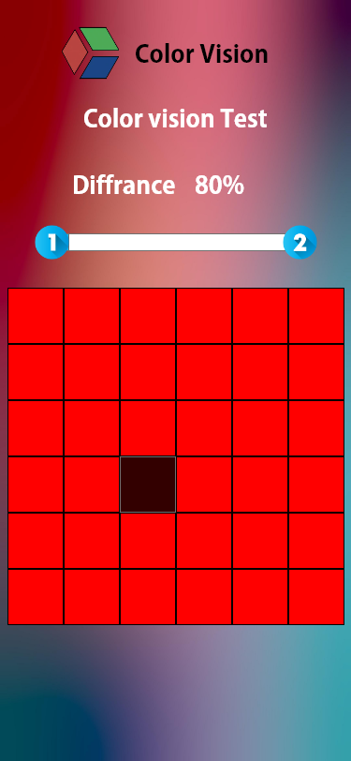

## 2.1 System: Levels

* The level system will depend on the smallest difference can the user see in the game
* level 1 : can detect objects with a slightly different color from 100% - 30%
* level 2 : can detect objects with a slightly different color from 30% - 20%
* level 3 : can detect objects with a slightly different color from 10% - 20%
* level 4: can detect objects with a slightly different color from 1% - 10%

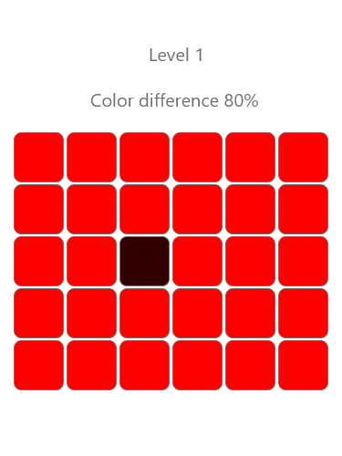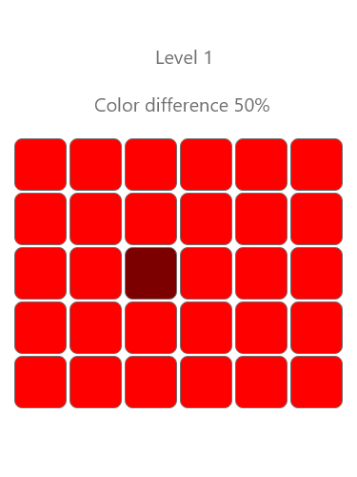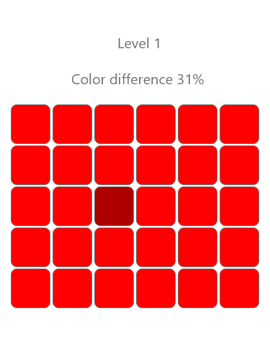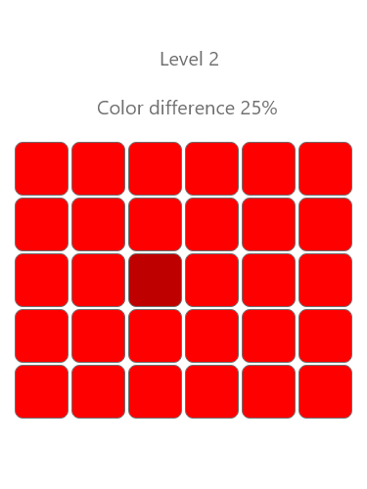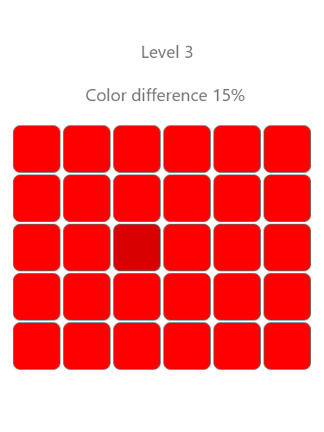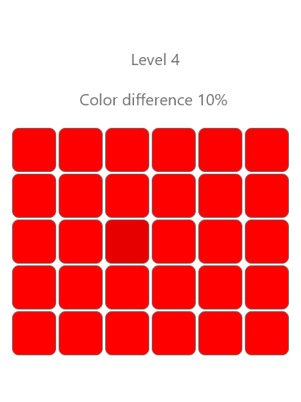

# 3 Game mode: Color of a day

the player will start will 0 points.  
Every day will receive a random challenge from the challenges list. and this challenge will be scored out of 100, and his achieved score from the challenge will add to his global score and added to the worldwide Leaderboard.

# 4 Game mode: Soical battle

2 players in the same level will versus each other in the same challenge.  
the challenge will be divided into 3 different challenges from the game list.  
for each challenge, they will get a score based on how they played on the challenge.  
in the end, will see the other score and who is the winner.